**DBMS LAB 9**

**PROGRAM 9: MOVIE DATABASE**

Consider the schema for Movie Database:

ACTOR(Act_id, Act_Name, Act_Gender)

DIRECTOR(Dir_id, Dir_Name, Dir_Phone)

MOVIES(Mov_id, Mov_Title, Mov_Year, Mov_Lang, Dir_id)

MOVIE_CAST(Act_id, Mov_id, Role)

RATING(Mov_id, Rev_Stars)

**Create database movie;**

**Use movie;**

**create table Actor**

**(**

**act_id integer primary key,**

**act_name varchar(100),**

**act_gender varchar(10)**

**);**

**create table Director**

**(**

**dir_id integer primary key,**

**dir_name varchar(200),**

**dir_phone varchar(100)**

**);**

**create table Movies**

**(**

**mov_id integer primary key,**

**mov_title varchar(255),**

**mov_year year,**

**mov_lang varchar(100),**

**dir_id int,**

**foreign key (dir_id) references Director(dir_id)**

**);**

**create table Movie_cast**

**( act_id int,**

**foreign key (act_id) references Actor(act_id),**

**mov_id int,**

**foreign key(mov_id) references Movies(mov_id),**

**role varchar(100),**

**primary key(act_id,mov_id)**

**);**

**create table Rating**

**(**

**mov_id integer primary key ,**

**foreign key(mov_id) references Movies(mov_id),**

**rev_stars integer**

**);**

**insert into Actor values**

**(1001, 'Tom Crusie','M'),**

**(1002, 'Chris Hemsworth','M'),**

**(1003, 'Angelina Jolie','F'),**

**(1004, 'Margot Robbie','F'),**

**(1005, 'Kate Winslet','F'),**

**(1006, 'Robert Downey','M');**

**insert into Director values**

**(9001, 'Hitchcock',9874562154),**

**(9002, 'Steven Spielberg',9874560054),**

**(9003, 'Joseph Levitan',9874562178),**

**(9004, 'Christopher Loyd',9874564454),**

**(9005, 'Yash Chopra',9874562994),**

**(9006, 'Tom Jones',9874503154);**

**insert into Movies values**

**(101,'Iron Man',2014,'English',9001), (102,'Prosperity',2001,'Spanish',9001), (103,'Spiderman',1998,'English',9002), (104,'Star Wars',1999,'English',9003), (105,'Thor',2017,'English',9002),(106,'Captain America',1994,'English',9004);**

**insert into Movie_cast values**

**(1001,101,'Joey'),**

**(1001,102,'Conor'),**

**(1002,102,'Tim'),**

**(1003,103,'Kate'),**

**(1004,104,'Claire'),**

**(1006,105,'Sally'),**

**(1005,106,'Jo'),**

**(1002,106,'Craft'),**

**(1002,104,'Josh'),**

**(1005,105,'Roy');**

**insert into Rating values (101,4),**

**(102,3),**

**(103,5),**

**(104,2),**

**(105,4),**

**(106,3);**

Write SQL queries to

i.List the titles of all movies directed by ‘Hitchcock’.

**select mov_title from Movies where dir_id in (select dir_id from Director where dir_name='Hitchcock');**

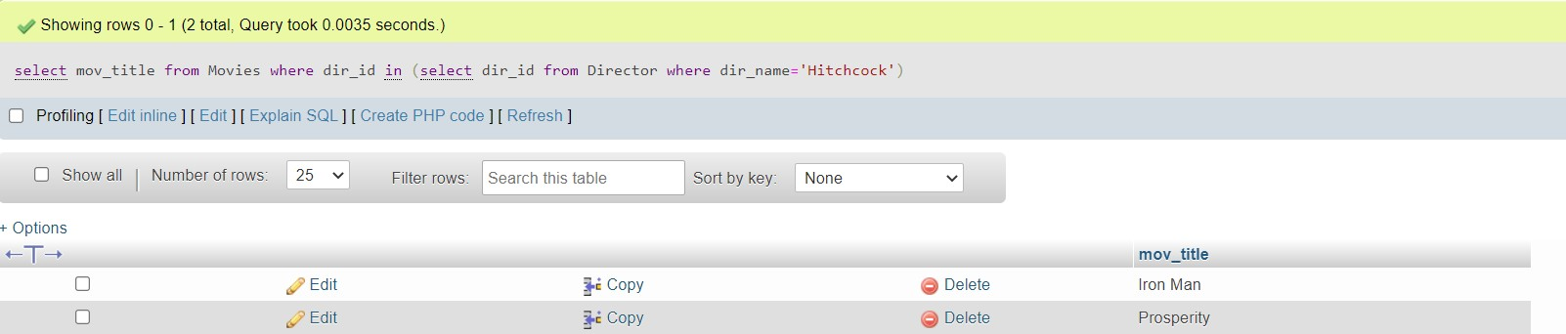

ii.Find the movie names where one or more actors acted in two or more movies.

**select distinct m.mov_title,c.act_id from Movies m, Movie_cast c where m.mov_id=c.mov_id and**

**c.act_id in (select act_id from Movie_cast group by act_id having count(mov_id)>1);**

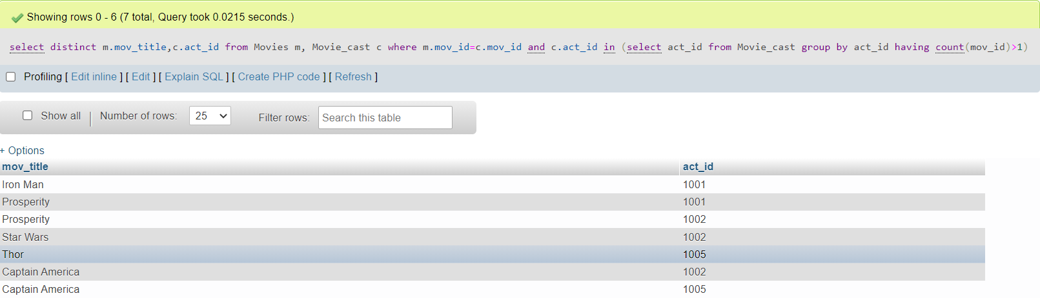

iii.List all actors who acted in a movie before 2000 and also in a movie after 2015 (use JOIN operation).

**select act_name from Actor whereact_id in(select a.act_id from (select act_id from Movie_cast natural join Movies where mov_year<2000)a inner join (select act_id from Movie_cast natural join Movies where mov_year>2015)b on a.act_id=b.act_id);**

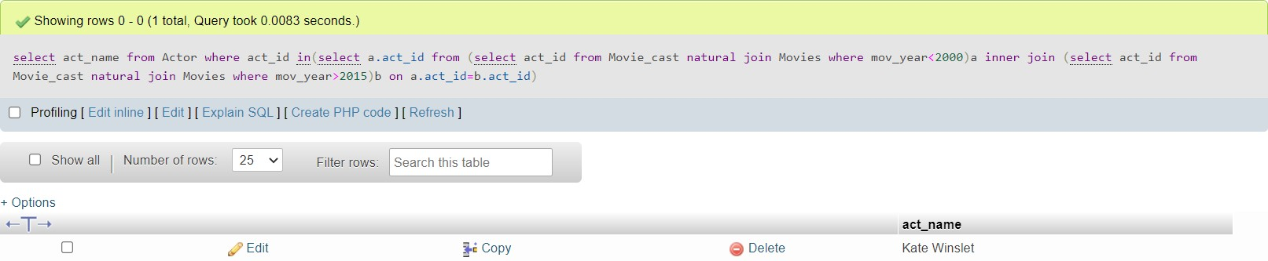

iv.Find the title of movies and number of stars for each movie that has at least one rating and find the highest number of stars that movie received. Sort the result by movie title.

**Select mov_title, max(rev_stars) from movie inner join rating using(mov_id) group by mov_title having max(rev_stars)>0 order by mov_title;**

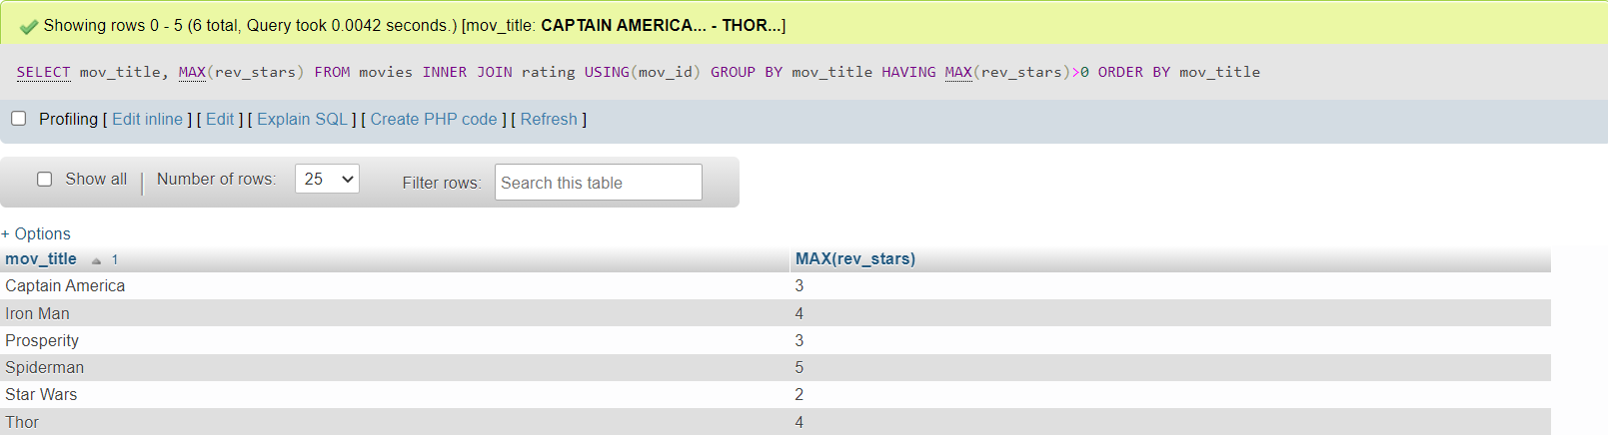

v.Update rating of all movies directed by ‘Steven Spielberg’ to 5.

**update Rating set rev_stars=5 where mov_id in (select mov_id from Movies inner join Director on Movies.dir_id=Director.dir_id and Director.dir_name='Steven Spielberg');**

